Klasa 4 Karta pracy Unit 6
Proszę o uzupełnienie i odesłanie karty na pocztę email - 8.04.2020 godz 19:00.
1 Podpisz obrazki wyrazami z ramki.
clean fat old young dirty thin

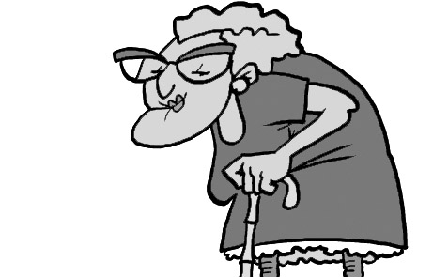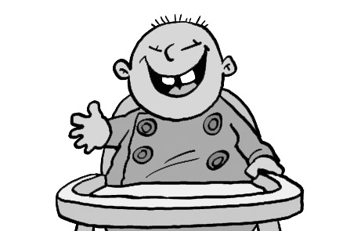
1 ______old_______ 2 ________________
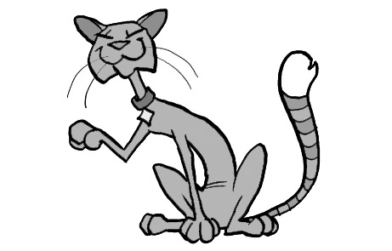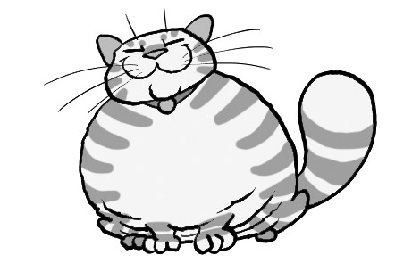
3 ________________ 4 ________________
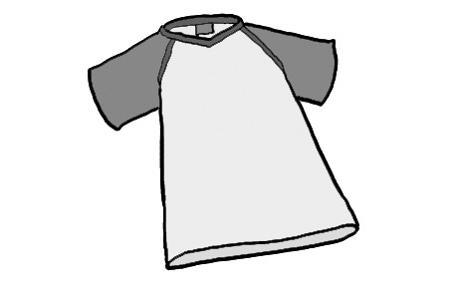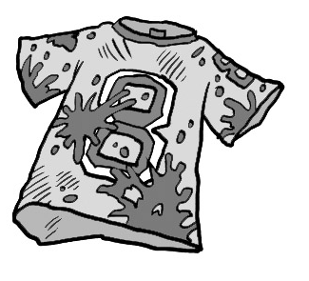
5 ________________ 6 ________________
Grammar
2 Z podanych wyrazów ułóż pytania. Następnie zakreśl właściwą odpowiedź.
1 curly / hair / got / your / cousins / have?
Have your cousins got curly hair?________
Yes, they have. / Yes, they’ve.
2 Mark / got / hair / has / blond?
______________________________________
Yes, he’s got. / Yes, he has.
3 has / got / baby / aunt / your / a?
______________________________________
No, she hasn’t. / No, she haven’t.
4 parents / eyes / got / your / have / blue?
______________________________________
No, it hasn’t. / No, they haven’t.
5 a / notebook / you / got / have?
______________________________________
Yes, I’ve. / Yes, I have.
6 got / fur / we / have?
______________________________________
No, it hasn’t. / No, we haven’t.

3 Połącz odpowiednie zdania.
1 Jack and I are twins. _d_
2 Lucy’s brother is ten. ___
3 I’ve got two sisters. ___
4 Amy is very tall. ___
5 Ben has got a dog. ___
6 This isn’t my pen. ___
a They’re bossy.
b His name is Sam.
c Your name is on it.
d Our birthday is in May.
e Her sister is short.
f Its tail is long.
4 Uzupełnij zdania, wpisując This, That, These lub Those.
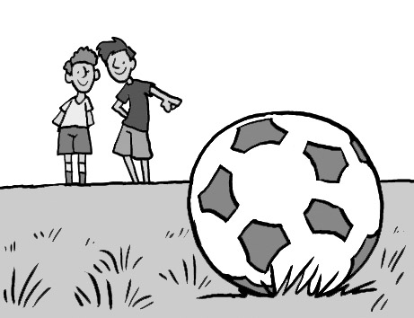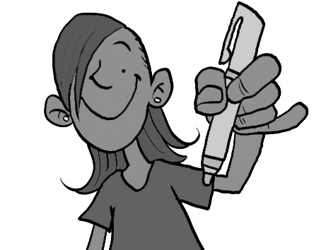
1 __That__ is our 2 ________ is my pen.
football.
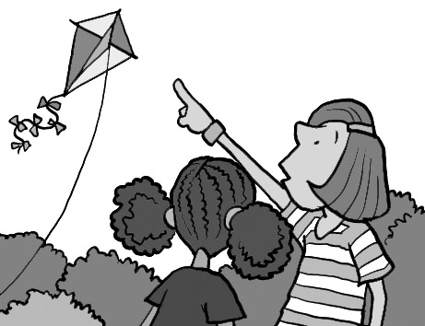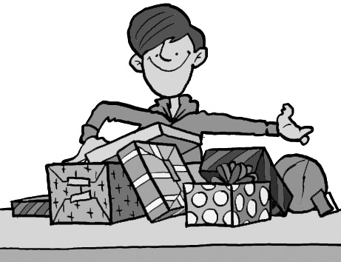
3 ________ is our kite. 4 ________ are my
presents.
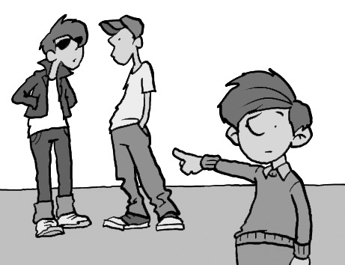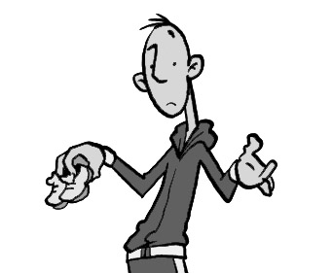
5 ________ are my 6 ________ aren't my brothers. shoes!
Reading
5 Przeczytaj tekst. Oznacz zdania jako prawdziwe () lub fałszywe ().

My name is Sara. I’ve got one sister, Grace, and two brothers, Adam and Jack.
Grace has got curly, blond hair and brown eyes. Adam has got curly, blond hair too, but his eyes are blue. Jack has got big, blue eyes, but he hasn’t got any hair. He’s a baby!
We’ve got a nice house with a big garden. We’ve got a puppy, too. Her name is Daisy and she’s very friendly!
1 Sara has got two sisters.
2 Sara’s brothers are Adam and Jack.

3 Grace has got straight, blond hair.

4 Jack has got blue eyes.

5 They’ve got a small garden.

6 Daisy is a baby.

Speaking
7 Uzupełnij dialog wyrazami z ramki.
sure I haven’t any about nice Really

Leah Have you got ¹___any___ brothers and sisters, Jack?
Jack Yes, I have. I’ve got four sisters.
Leah ²__________? What a big family!
Jack Yes, but it’s fun! What ³__________ you? Have you got a big family?
Leah No, ⁴__________. I’ve got one brother, Paul.
Jack That’s ⁵__________.
Leah I’m not ⁶__________. He’s very noisy!
Writing
8 Połącz zdania za pomocą spójnika and lub but.
1 Jenny is good at art. She isn’t good at music.
Jenny is good at art, but she isn’t__________
good at music.______
2 My sister can ride a horse. She can ride a bike.
____________________________________
3 Robert has got dark hair. His sister has got blond hair.
____________________________________
4 Lucy has got brown hair. She’s got brown eyes.
____________________________________
5 I’m good at maths. I’m good at science.
____________________________________
6 Josh can run fast. He can’t play football.
____________________________________
Extra
9 Zakreśl wyraz, który nie pasuje do pozostałych.
1 netball / school / baseball / hockey
2 birthday / present / height / party
3 mobile phone / text message / kick boxing / computer
4 Trinidad / China / England / Boston
5 curly / straight / noisy / long
6 amazing / blond / great / cool

Imię i nazwisko ……………………………………
Ocena ………………..

