Sziasztok!

A mai nap a születésnapokról fogunk olvasni. Ha valakit érdekel atankönyv 11. Oldalán a 8 a és b feladatokat próbáljuk majd megoldani.
Figyelem! Mindenki küldje vissza a házikat, mert az online/távoktatási aktivitásotokat így mérjük fel és beleszámít az értékelésetekbe. Próbáljátok megoldani a feladatokat, ha problémátok lenne velük, azt a papíron vagy az osztályfőnökön keresztül megüzenhetitek.

- Feladat Nézzétek meg a képet, karikázzátok be hol vannak a következő dolgok:

- Birthday cards
- A birthday cake
- Birthday presents
- Candles

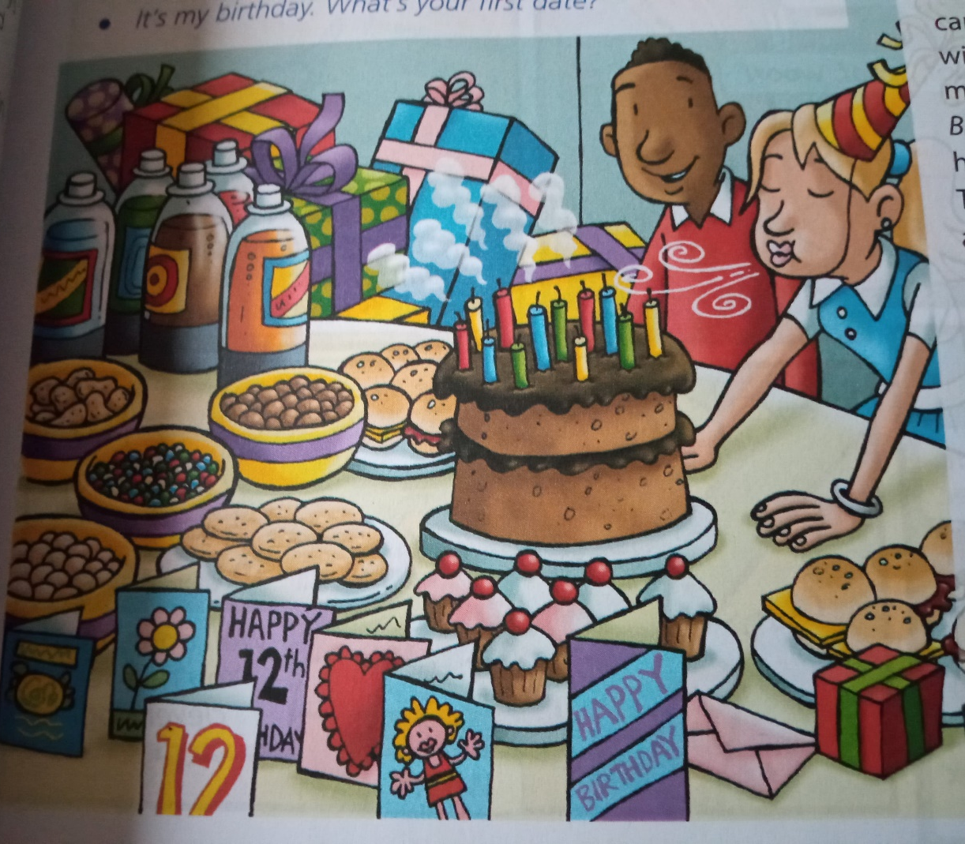

- Feladat Olvassuk e a szöveget és próbáljuk meg lefordítani.

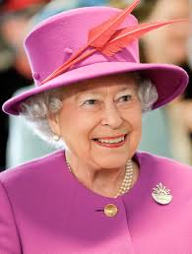Birthdays in Britain 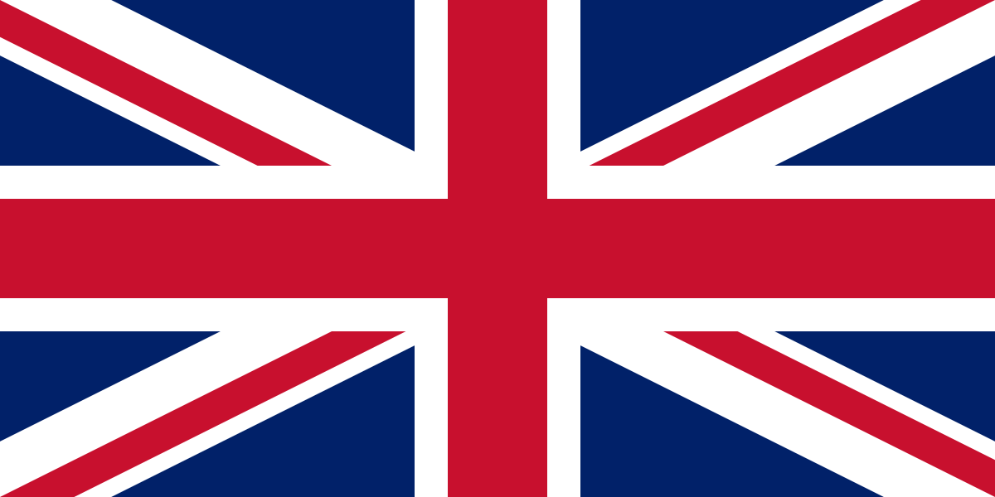

On your birthday you get cards and presents from your family and friends. Parents often buy a big present like a bike or MP3 player. Other people give toys, sweets, books, clothes, CDs, DVDs and things like that.
People normally have a birthday party for their friends. There’s usually a birthday cake with one candle for each year of your age. The person with the birthday blows out the candles and makes a wish. Then everybody sings Happy Birthday! People often have a party in their own home. Some older friends don’t have a party. They take their friends to the cinema, a bowling alley or something like that.
My friend, Karl, in the Czech Republic, says that they have ‘name days’ in his country, but we don’t have ‘name days’. Karl also says that people in the Czech Republic give flowers on name days and birthdays. In Britain, we usually only give flowers to women. Alison and I give flowers to our mum on her birthday.

- Feladat válaszoljatok a következő kérdésekre:
- What do people give to someone on their birthday?
- Does everyone have a party?
- Where do some older children go on their birthday?
- Do people in Britain have ‘name days’?
- Do people give flowers?

